Clock State Model Project Design Brief

General Overview
This project was created as part of the requirements of the technical task phase for the position of QA Student Worker at Unity Technologies. The project requirements were received Wednesday 29th July 2020, with the submission deadline set for Wednesday 6th August 2020. Due to a second project forming part of the requirements for the technical phase, this project was scoped to be completed by Friday 31st July 2020, allowing adequate time to complete the second task and extend the feunctionality of this project beyond its requirements (if time allowed so).

Project Requirements
The original requirements of the project were outlined in a design brief, which can surmissed as developing a clock radio that implements a state system:

Functional Requirements:
- The device can be turned on or off
- The alarm time can be set IF the time is set
- The alarm can be on or off
- The alarm can be set to on IF the alarm time is set.
- If the alarm is ringing, you can snooze 2 times for 10 minutes

Submission requirements:
- Create the state diagram for the alarm clock
- Point out problems with the requirements if you encounter any
- Create a set of tests based on your model.
- Make assumptions about your model explicit.

Initial Design and Intepretation of the Requirements

Initial State Machine Design
Despite some ambiguity in the requirements of the project, i surmissed that the core tenet of the implementation requirements was that the clock system shiould be based off a 'State' design pattern. Although state design patterns can be quite broad in definition and implementation, my first design revolved around a method of state machine implementation that adheres to the principles of SOLID, respects open/closed principle, is scaleable, and architectural sound.
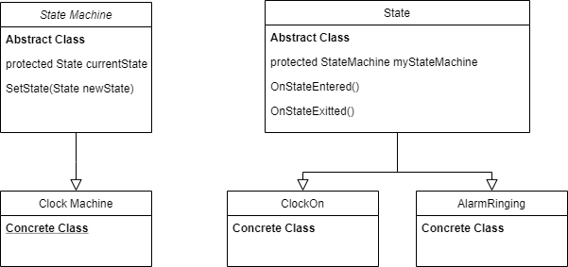
However, after some initial implementation, i realized this design pattern was not suitable for the project, and my attempt to implement this pattern exposed some flaws in the project requirements.

Contradictions Between State Design Pattern and the Requirements
Sound state design dictates that an object should be in one state, another state, or no state, but never multiple states simultaneously. However, the requirements of the project suggested that the clock could be in multiple different states at any given time. For example, it is possible for the clock to be in a state of 'Turned On' and 'Alarm Ringing'.

The main appeal of state design pattern (at least for me personally) is that an object that is acted upon by external stimuli and code responds in a controlled and predictable manner that is dictated by it's state. E.g. If 'Scenario One' occurs and i am in state A, do something. If 'Scenario Two' occurs, and i am in state B, do something else. This allows developers to write readable, scaleable code and prevent 'Spaghetti Code'. By allowing a state machine to be in multiple states simeoutaensly, the amount of responses a state machine requires to effectively respond to external stimuli multiplies drastically, leading to long and messy switch and else/if statements(a.k.a. 'Spaghetti Code'): one of the main things were supposed to avoid by using a state design pattern.

Second State Design Pattern
After experimenting and failing with my initial state design pattern, i decided to implement a simpler system that breaks from sound state design practices, but allowed me to meet the requirements of the project with a system that at least somewhat resembles a state machine. The new state design was based off 3 categories of enums: power state, alarm state, and time set state. The clock implements and tracks all 3 states, and its responses are limited (where possible) to only consider one type of state when responing to stimuli in order to prevent messy code and states contradicting each other in responding to events (e.g. only consider the power state or the alarm when responding, never compare the two states at the same time).

Enum Based State Model Flow Diagram

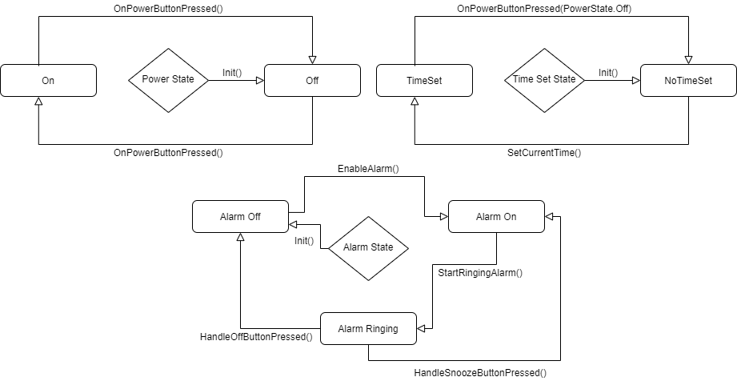
Contradictions Between State Design Pattern and the Requirements

